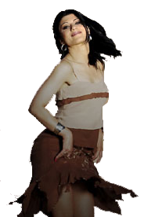
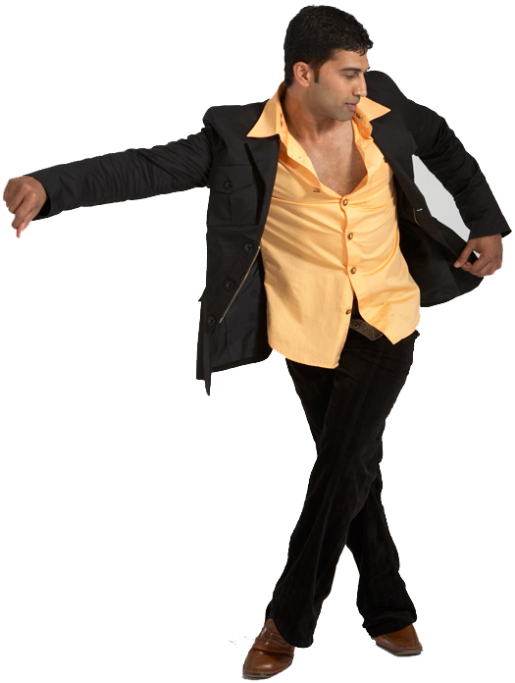
By Popular demand,

team up for a much anticipated



In the South bay on March 29th, Saturday

This 3-hr workshop will cover on2 basic techniques, shines, men’s and ladies’ styling and partnering moves. If you are a beginner interested in venturing into on2 or an intermediate dancer wanting to brush up on2 skills and techniques, this workshop is designed for you..!!
Time: 2:00-5:00p
Workshop Date: Saturday 03/29/07
Place: Susan's Dance Studio,2146 Ringwood Avenue,San Jose, CA 95131

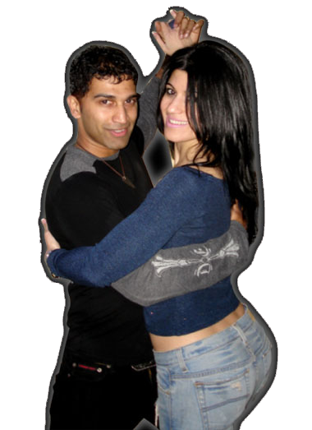
Cost: $40

Contact: giju_John@yahoo.com or salsawithpantea@gmail.com
or gunter.marie@gmail.com

http://www.beyonddreamz.com
http:/www.salsawithpantea.com

Mark your calendar for this on2 salsa experience with us..!!!

