BEYOND DREAMZ ENTERTAINMENT
presents . .


With

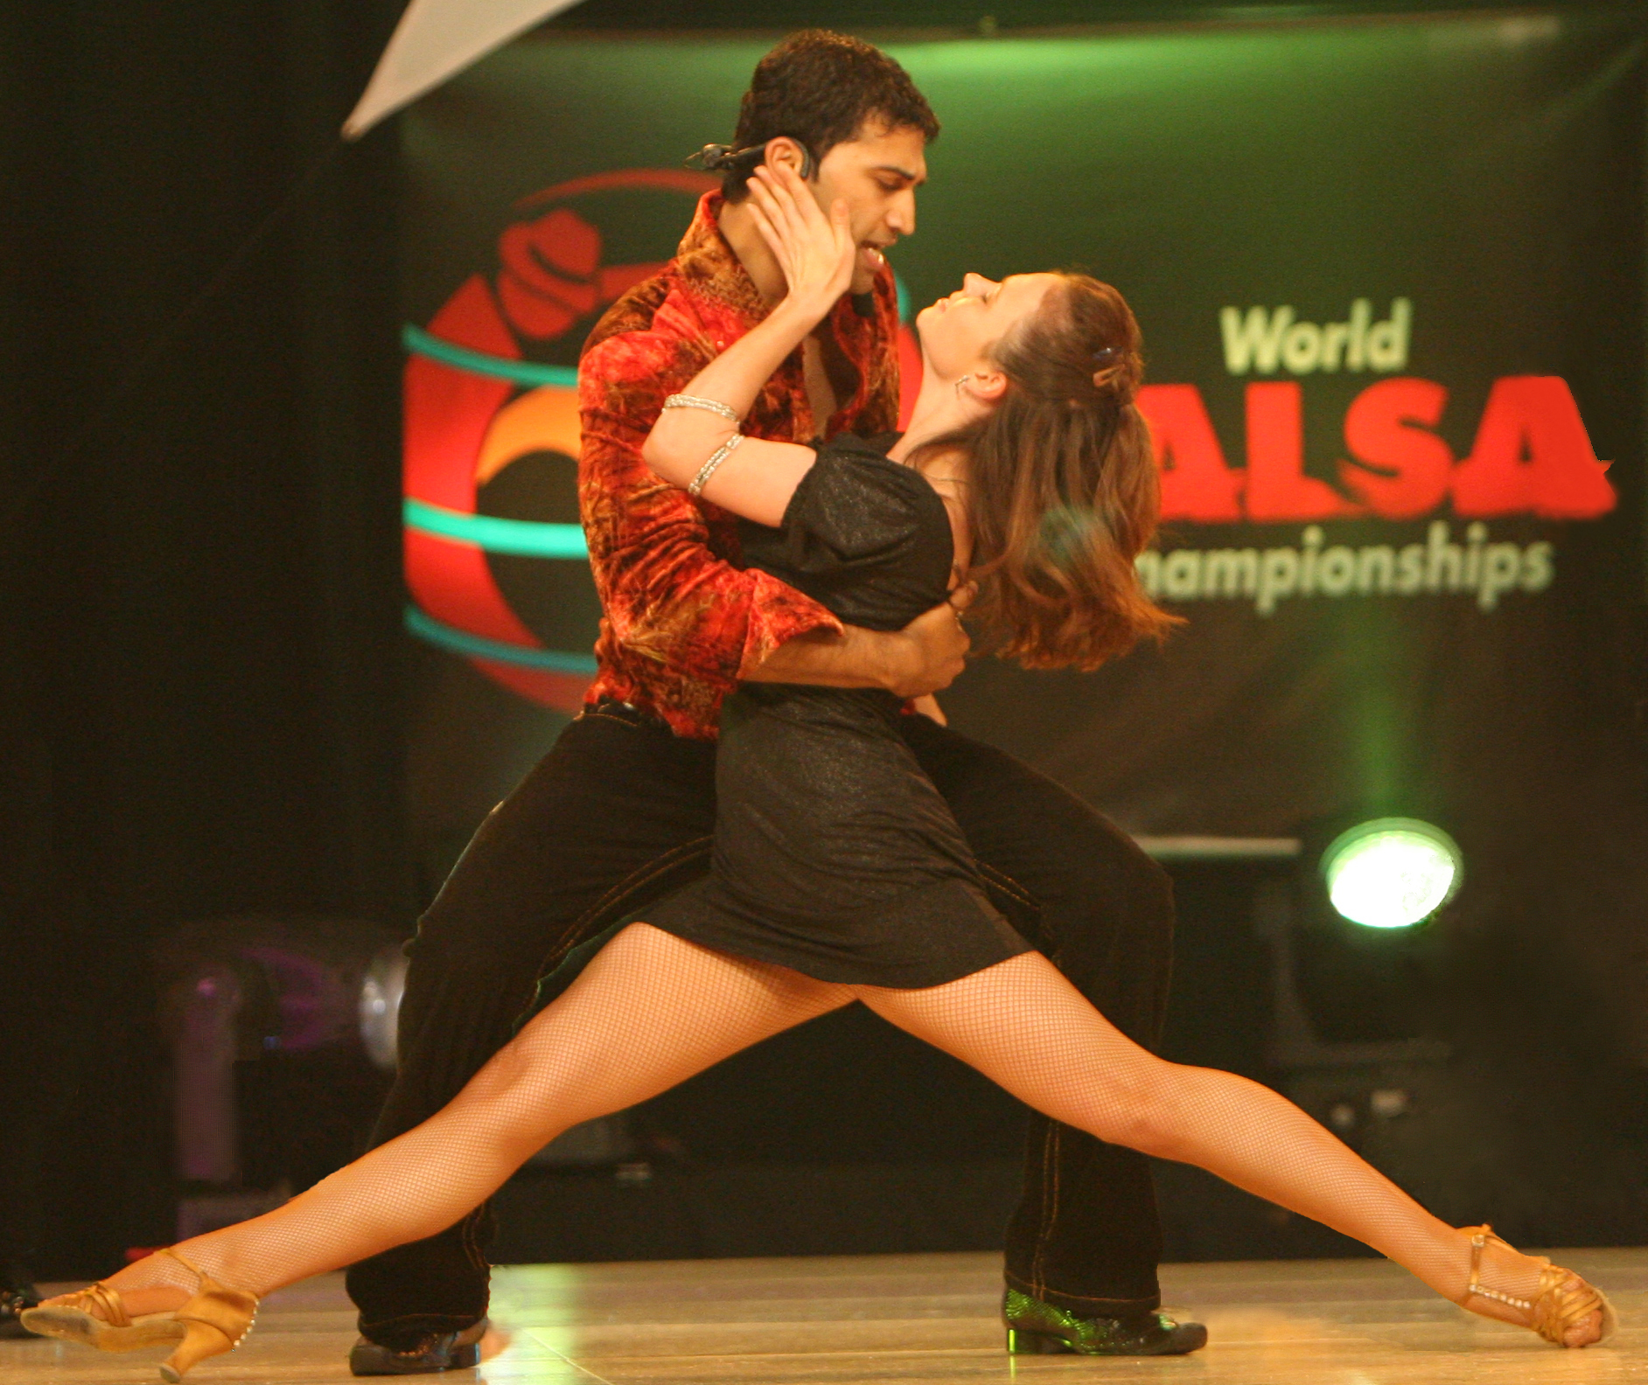
Take your dancing to the next level..!!!!

Register Now..

Progressive 4 Week Workshop in June 2008

Beginner/Intermediate level

•salsa basics •body isolations •styling •spin techniques •shines •patterns and much more..!!

Grab this opportunity to learn from the world renowned dancers & performers.

Time: 11:00am-1:00pm
Workshop Dates: Saturday 6/7, 6/14, 6/21, 6/28
Place: Alameda School of Dance, 1402 Park St, Alameda, CA 94501
Cost: $20/ea or $75 for full series in advance

Gain valuable assistance and useful dance tips from the Beyond Dreamz dance team.

We will also be holding auditions for Beyond Dreamz company. Try it out!!

Contact: giju_john@yahoo.com or gunter.marie@gmail.com

